**Task 3 Screenshots**

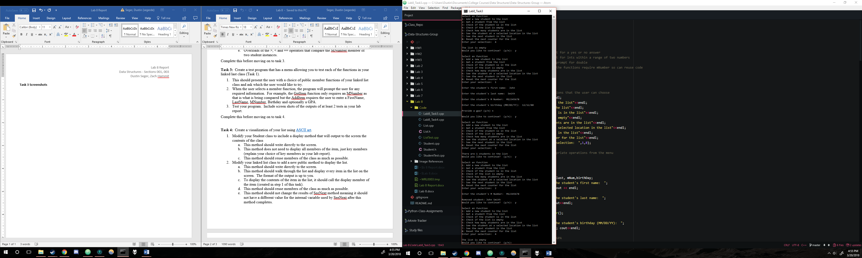

Figure 1 - Add / remove item tests

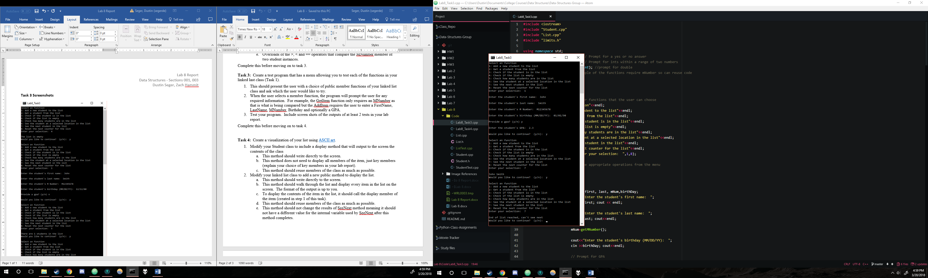

Figure 2 –“ See next” test

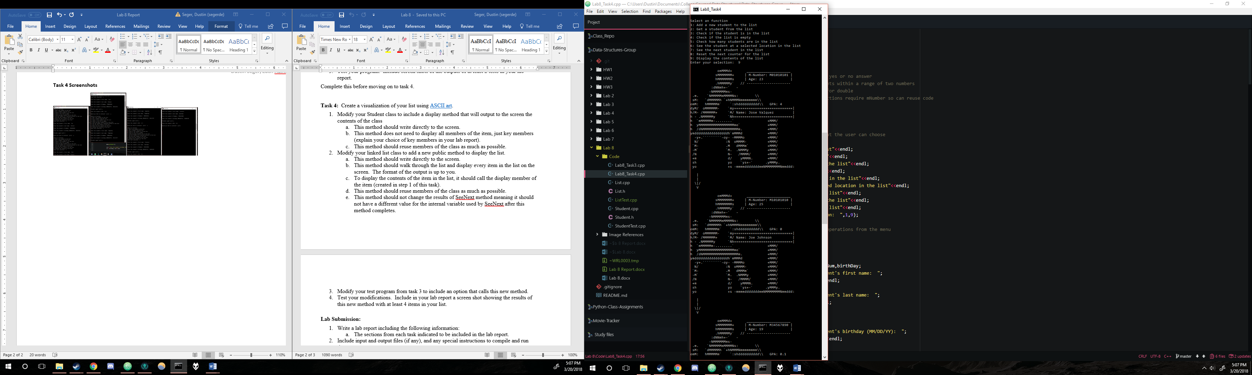**Task 4 Screenshots**

Figure 7 - ASCII output (part 1)

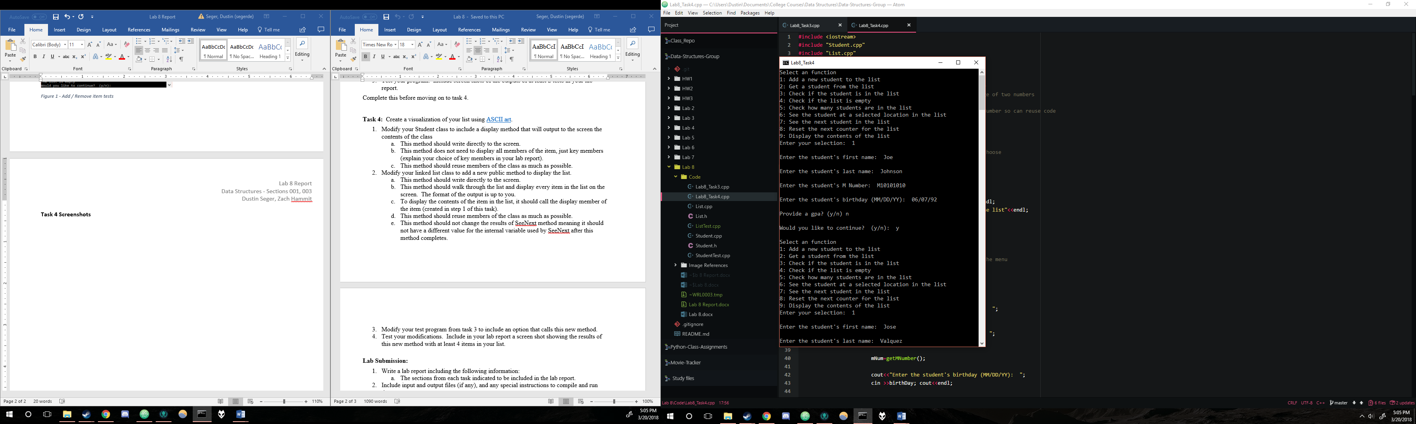

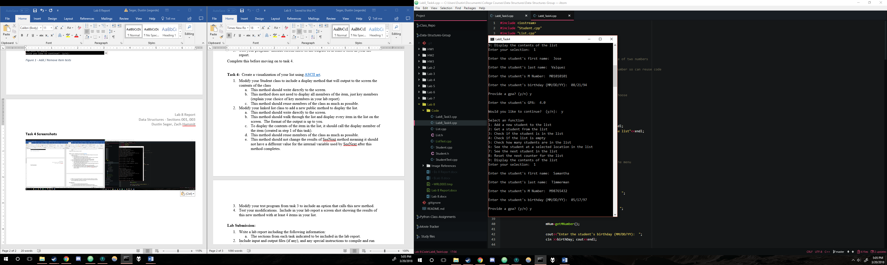

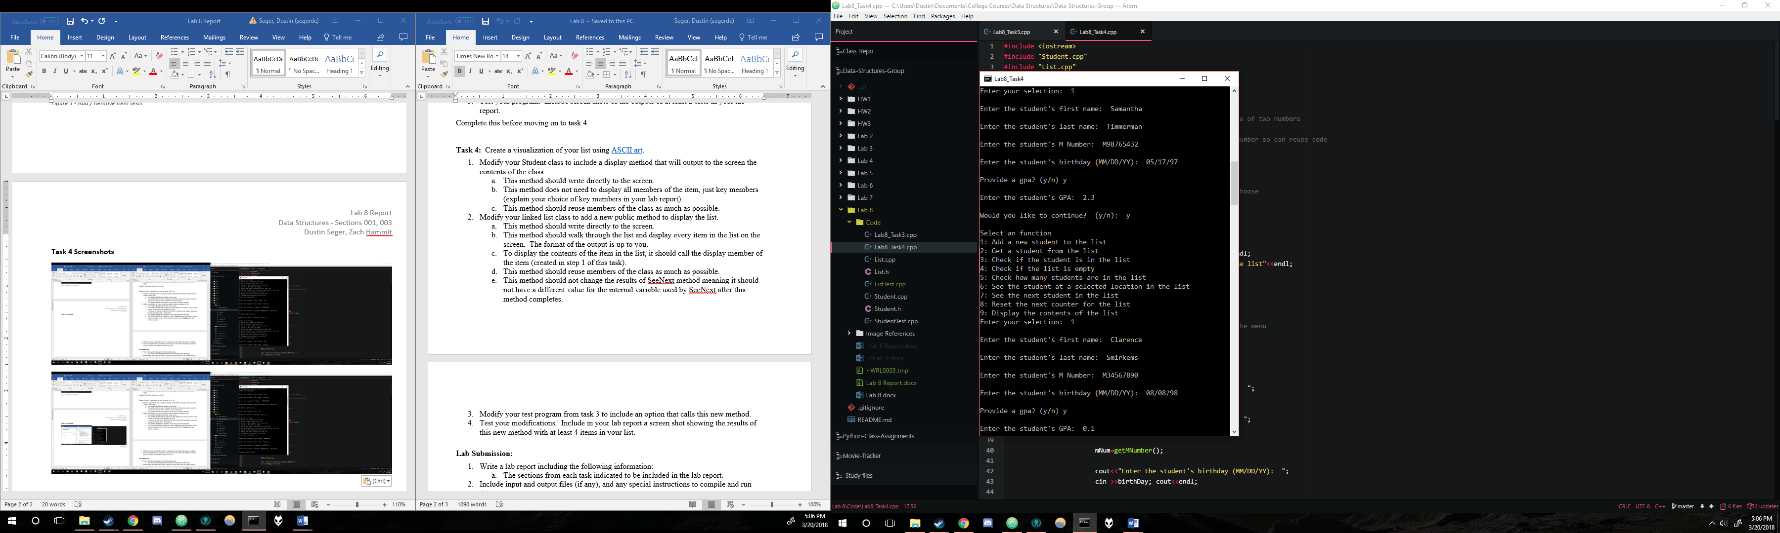

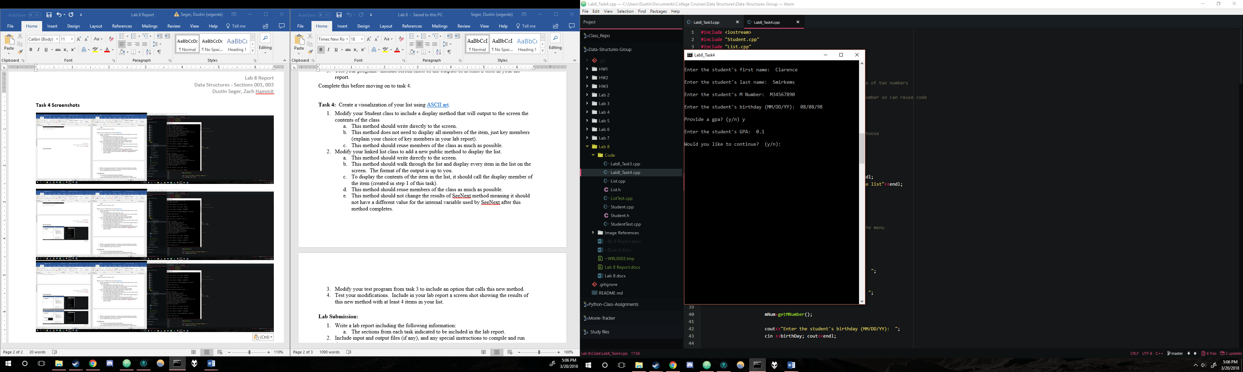

Figures 3-6 - Student input information

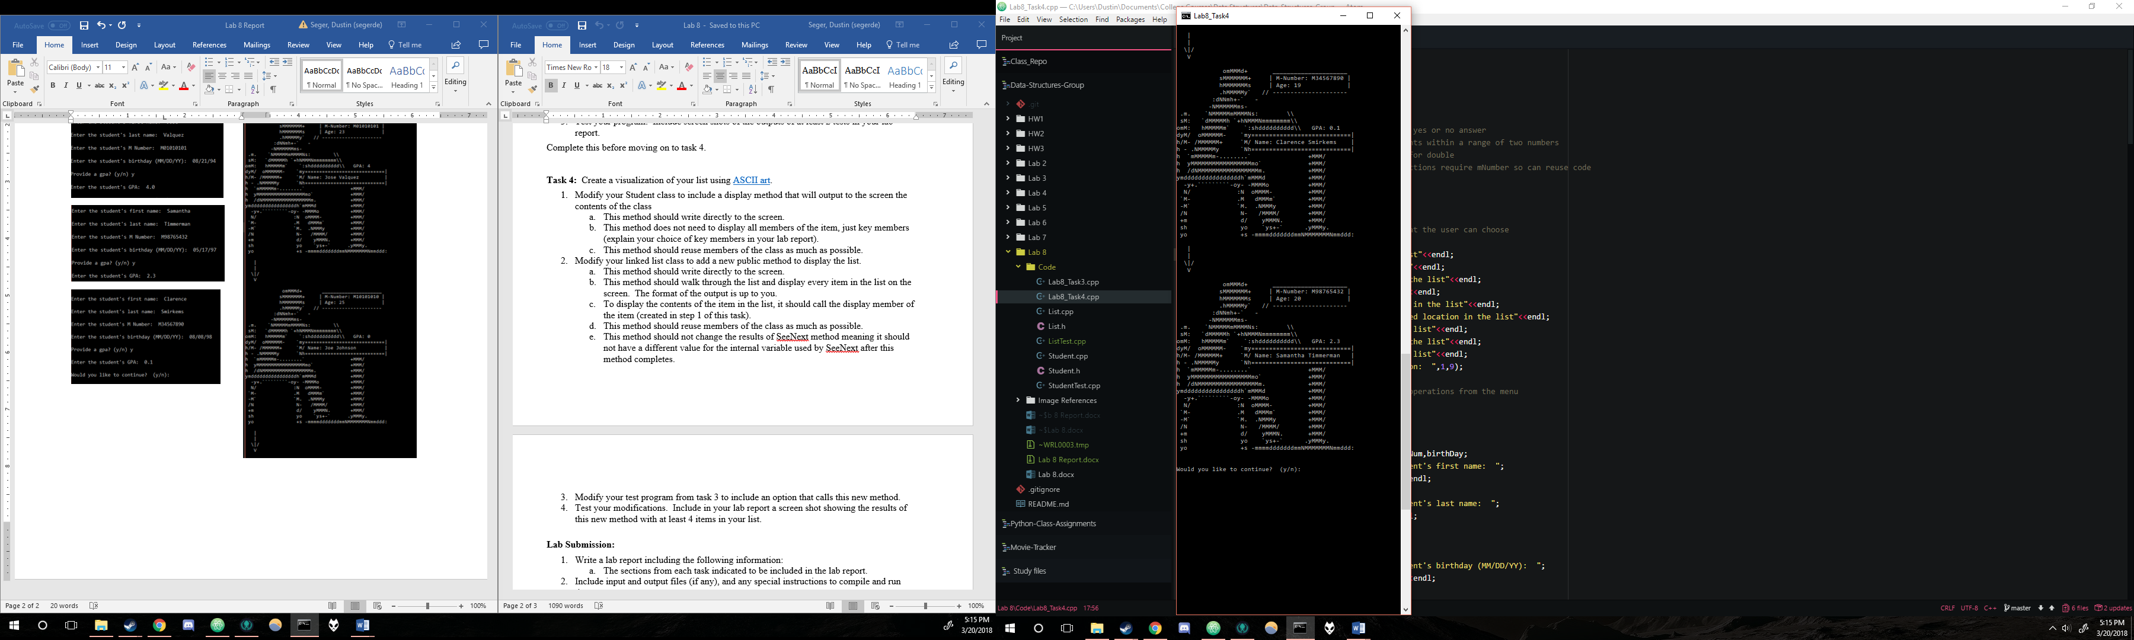

Figure 8 - ASCII output (part 2)

**Discussion**

In Task 4, we were asked to display only the key members of the student item. For our purposes, we chose to use all the members except for date of birth which was swapped for an age component. Name and M-Number were kept as key members because they can help to uniquely identify a student in their own ways. A name without an M-Number could create confusion if two students have the same name, and an M-Number without a name is hard to process and read as a human being. Thus, they balance each other out, and keeping them together is ideal for our purposes. We also kept GPA and swapped out the date of birth member with an age display that uses our getAge member function. These are not required for the user to see, but we felt that it would help add some additional insight into the student that is fairly simple to add to the ASCII art. We used the age of the individual instead of the date of birth because it’s easier for the user to understand and allows for a bit cleaner art.

Task 4 simply asked for the addition of a menu item that displays the information using ASCII art. Naturally, the linked list and student classes required modifications to include functions that would display the information. The main function was also modified to add the option to the menu and make the new display functions accessible. However, the rest of the code was simply reused due to our proper pre-planning and open-ended design of the student and linked list classes. No code was rewritten for this task.

**Contributions**

Zach created the main function and the Student class.  
Dustin created the linked list class and implemented the Task 4 display functions.  
The work is equitable.

**Compilation Instructions**

All programs should be compiled using the g++ compiler with default Windows settings.

Lab8_Task3.cpp correlates to Task 3

Lab8_Task4.cpp correlates to Task 4

The image file included is simply our reference image for the ASCII art. It is not required for compilation.